ADLookup Help

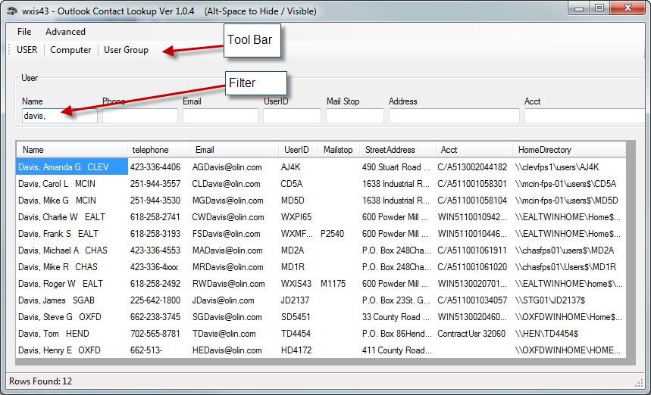

Adlookup is a simple program to easily look up AD information about users and computers. The program loads with user info from olindc01.olincorp.net.

The program will help you find user info by filtering down the list.
As you type in any of the text boxes the list will filter on each letter typed. It will filter for each letter looking for that letter or word in any part of that column in the grid.
To clear the filter, just remove the typed letters in the text box.

By clicking on the Tool Bar buttons you will get one of the three lists to search from:

User Screen
Name User’s Full Name
Telephone # Phone Number
Email Email Address
UserID User’s Network ID
MailStop Mailstop
StreetAddress Full address
Acct Peoplesoft Acct Code
HomeDirectory Home Directory
MemberOf AdGroup user is a member of **
OU – Oufolder User is in AD. **

Computer Screen
Name – Computer Name
OS Operating System
SP Version of OS
ServicePrincipal
OU AD OU the computer is in.

User Group
Name Users’ Full Name
UserID Users Network ID
Group Name AD Group they belong to
OU AD Ou the user is in.

** Items that can be turned on or off in the advanced menu item for efficiency reasons.

The menu items are as follows:
File
- Exit Exits Program
Advanced
- Grid
  - Show Grid Lines - Turn Grid lines on off
  - Reset Column Widths Resets all column widths back to default.
- UserList - Making changes to add / remove columns in the user listing
  - Add MemberInfo Adds memberof column and ou folder info to grid.
- Trouble Shooting
  - Show Logs Allows the ability to see applications log file
located at \\ealtwincommon\common\adlookup\log

Grid functionality
- Sorting: Every column is sortable by clicking on the column header
- USERID: If you double click on the USER ID you will get a window that pops up showing
lots of info for the specific user you clicked on -- dbl click on UserID
User Name | Full Name | Comment | Account Active
Account Expires | Password Last Reset | Password expires | Password Changeable
Password Required | User May Change Password | Workstations Allowed | Logon Script
Home Directory | Last Logon | Logon Hours Allowed | Local Group Memberships
Global Group Memberships

Email Address : If you double click on the Email Address
It will open a new outlook email with that user in the To box.

Memberof:
If you double click on the MemberOf cell of a user, a window will popup with all the groups that user is a member of. You can also put your mouse over the Memberof Cell and you will see the same list in a tool tip that goes away after a few seconds.

Grid Right Click Menu Items
  - Ping Ability to ping a machine when on the Computer Info
  - SCCM Info Shows info from SCCM about machine (Hardware, Auto Start, Add / Remove Programs, Files, Services etc)
  - Dameware Machine If Mini Remote is installed and if on computer Info screen)
  - Remote Desktop Machine Ability to start remote desktop from here

  - Added some more print functionality
    - Print Grid with all rows
    - Print Grid with just selected rows (Multi Select Rows)

  - Show User Info Summary - Shows Account
    - Active
    - Expires Date
    - Last Password Reset
    - Home directory
    - Last logon
    - Logon hours allowed
    - Group Memberships

SCCM info

